Home work:

To prepare for the masterclass

1. **Find out what the 6 dimensions from Hofstede are for Tanzania, try to explain the given numbers. Note: the numbers run from 0-120.**  
   To answer the question above, we first have to know what the 6 dimension from Hofstede are. Here is a summary:
   1. **Power distance**The extent to which the less powerful members of institutions and organization within a country expect and accept that power is distributed unequally.
   2. **Individualism**The degree of interdependence a society maintains among its members.
   3. **Masculinity**This score displays the reason that motivates and drives people. Do they want to be the best (masculine) of do they want to do what they like to do (feminine).
   4. **Uncertainty avoidance**The extent to which the members of a culture feel threatened by ambiguous or unknown situations and have created beliefs and institutions that try to avoid these.
   5. **Long term orientation**The way society has to maintain some links with its own past while dealing with the challenges of the present and the future.
   6. **Indulgence**

The extent to which people try to control their desires and impulses.

In the figure below, I’ve found a graph on: <https://www.hofstede-insights.com/country-comparison/the-netherlands,tanzania/> , that shows an estimation of Tanzania and the Netherlands on the 6D of Hofstede.

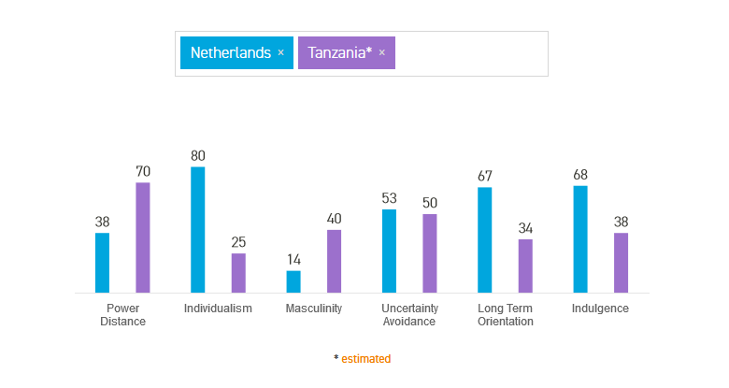

The graph shows that people in the Netherlands are less compliant with distance to power and that they ,compared to Tanzania, value their individualism as a person. In the Netherlands we are more leaning towards the ‘I’ instead of the ‘we’.

Furthermore, in the Netherland the people are a more feminine society than in Tanzania. So we value our quality of life in combination with our work.

Both countries have the same way of thinking about avoiding uncertainty’s, this can be used as a common ground.

Another difference is the pragmatic view of the Netherland versus the normative short-term oriented culture of Tanzania.

In the Netherlands we have a high tendency to give in to our impulses and desires. They tend to lean towards optimism, while in Tanzania they tend have a more restricted culture. They do not emphasis on free time and their own desires, they are more working towards the whole picture (family).

1. **What is the impact of this knowledge (Hofstede), or what does this mean for the implementation of your idea in the village?**

One of the biggest impacts this knowledge gives me, is that the work-, living- and free time culture differs a lot from the same cultures in the Netherlands.

It also shows that in the village in Tanzania cares more about the people in the village, than about the individuals in the village. This leaves an opportunity for the project to focus on the impact on the whole village instead of the impact on the villagers.

The long term orientation is an indicator that we maybe should not work towards one big goal in the future, but more towards multiple small goals that directly affect the village. So for the waterpump, we could split it in the digging and placing the pump, placing a filter, making transport easier, etc.